NAME: CLASS: Mark: 

Achievement Standards being tested
describe models of energy transfer and apply these to explain phenomena.
Mark | ND | NW | C | HC | O
Mark Range | 0-23 | 24-35 | 36-50 | 51-59 | 60-80

Content being tested
Forms of energy can be transferred in a variety of ways through different mediums (ACSSU182)
- exploring how and why the movement of energy varies according to the medium through which it is transferred
QUESTION | ANSWER
1
2
3
4
5
6
7
8
9
10
11
12
13
14
15
16
17
18
19
20
21
22
- investigating the transfer of heat in terms of convection, conduction and radiation, and identifying situations in which each occurs
- exploring situations where energy is transferred in the form of waves, such as sound and light
- investigating how the human body receives sound and light waves
----------------------------------------------------------------------------------------------

1 If you put a hot brick into a bucket of cold water, heat transfers from the:

A water to the brick
B brick to the air
C brick to the water
D air to the water

2 During heat transfer by convection:

A energy transfers through a substance, but none of the substance
itself moves
B energy transfers through liquids and gases by tiny currents that carry
the energy
C energy transfers across empty space or through another substance
without heating it
D conduction and radiation always occur as well

3 A substance is needed to transfer heat energy in the case of:

A radiation but not conduction or convection
B conduction but not convection or radiation
C conduction and convection but not radiation
D radiation and conduction but not convection

4 The electromagnetic energy we sense as heat is:

A infrared
B ultraviolet
C microwave
D light

5 Detecting underwater objects using sonar uses which property of sound?

A echoes
B reverberation
C pitch
D resonance
6 The three smallest bones in the human body are found in the:

A brain
B foot
C finger
D ear

7 A sound wave consists of:

A conductions and resonances
B compressions and resonances
C conductions and rarefactions
D compressions and rarefaction

8 The cochlea is:

A a snail-shaped bone in the ear that is the sound detector
B a thin skin covering at the end of the ear canal
C the ear flap made of spongy tissue called cartilage
D the hearing nerve that carries sound information to the brain

9 Sound energy is:

A energy in moving objects
B energy stored in objects that are raised
C energy released by vibrating objects
D energy stored in the nuclei of atoms

10 The part of the eye that contains specialised cells that convert light signals into electrical signals is the:

A iris
B lens
C retina
D optic nerve

11 The process where the lens in the eye can change shape and allow us to focus on near and far objects is known as:

A the near point
B the fovea
C accommodation
D short- and long-sightedness

12 The separation of white light into its component colours is known as:

A diffraction
B dispersion
C polarisation
D refraction

13 Thunder is heard after lightning is seen because:

A lightning occurs before thunder.
B eyes see faster that ears hear.
C sound travels slower than light.
D the clouds slow down the thunder, but clouds do not slow down lightning.

14 A sound wave consists of a series of alternate regions of high and low pressure called:

A vibrations.
B alternating frequencies.
C different media.
D compressions and rarefactions.

15 Questions 15 - 17 refer to the following diagrams.

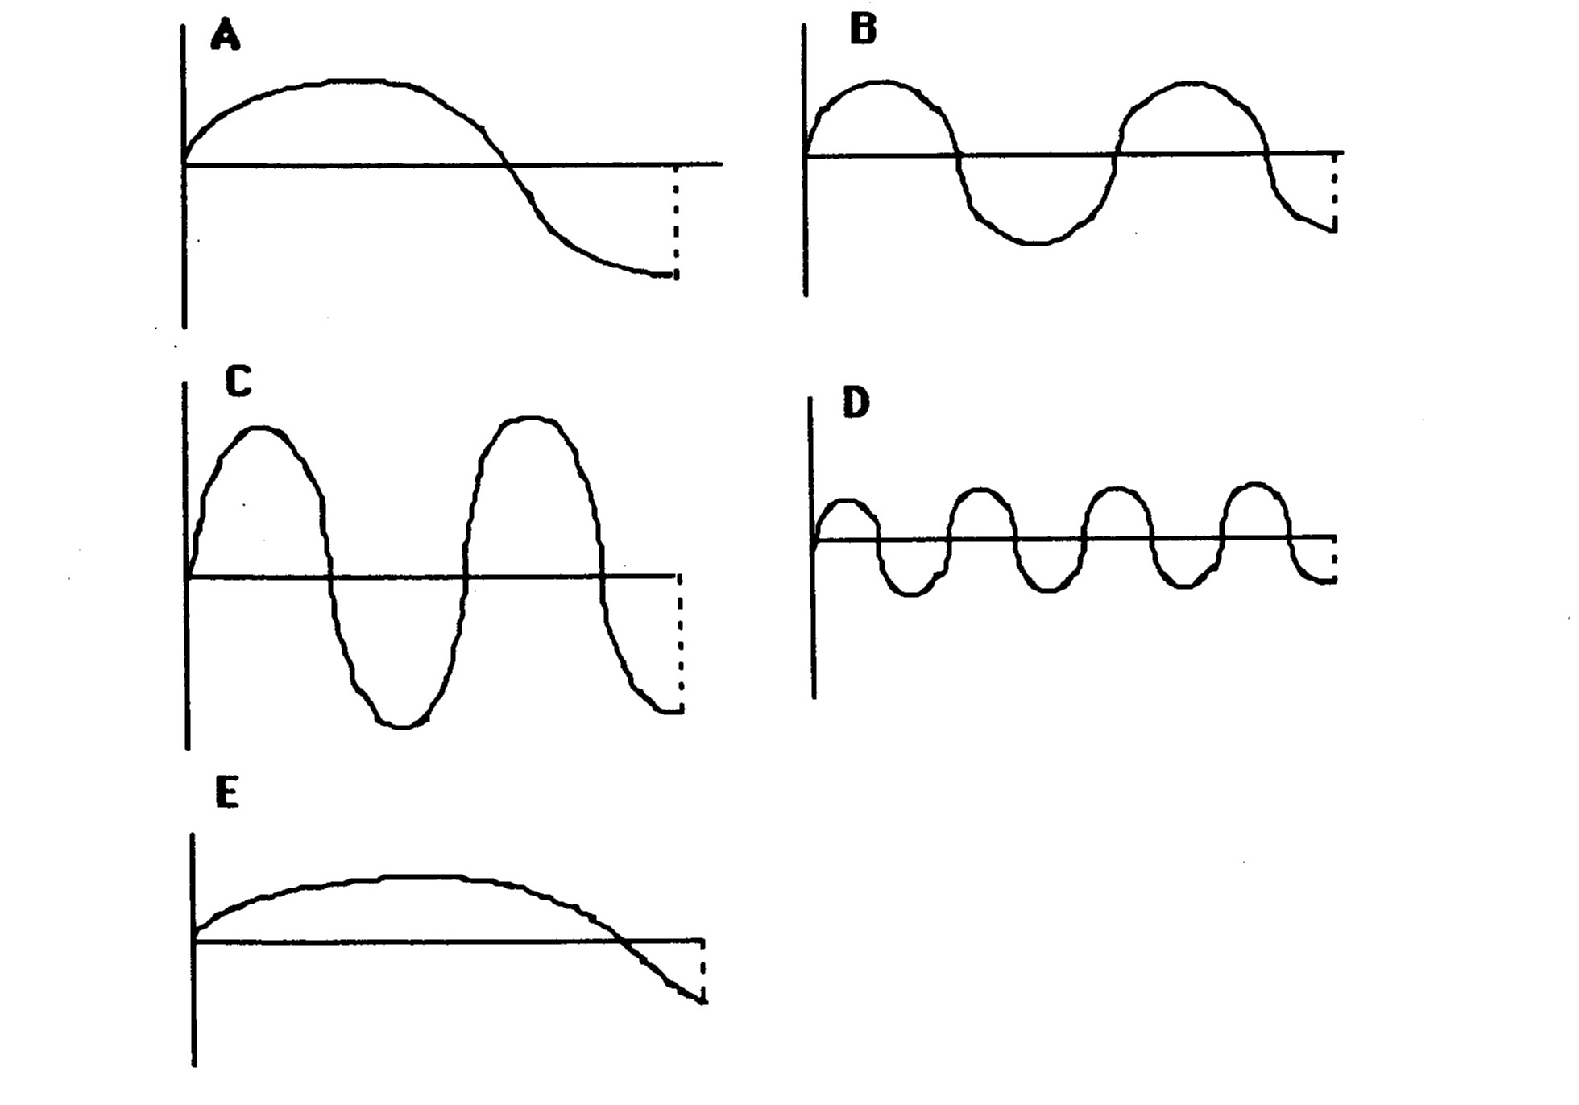

Which wave has the lowest frequency?

A A
B B
C C
D D
E E

16 The wave with the greatest wavelength is:

A A
B B
C C
D D
E E

17 The wave with the greatest amplitude is:

A A
B B
C C
D D
E E

18 Refraction of light is:

A the wave motion of light as it passes through a substance.
B the bending of light as it passes from one substance into another.
C a reflection of light rays at the surface of a medium.
D the failure of light to pass through a very dense substance.
E none of the above.

19 Light entering glass from air:

A speeds up slightly and bends towards the normal.
B speeds up slightly and bends away from the normal.
C slows down slightly and bends away from the normal.
D slows down slightly and bends towards the normal.

20 The greater the curvature of a convex lens:

A the more it bends light and hence the shorter the focal length.
B the more it bends light and hence the longer the focal length.
C the less it bends light and hence the shorter the focal length.
D the less it bends light and hence the longer the focal length.

21 Light travels in _____ lines.

A diagonal
B curved
C horizontal
D straight

22 A person standing on a bank beside a river attempting to spear a fish under the water must aim:

A below the apparent position of the fish because light rays coming from the fish are refracted
away from the normal when passing into the air.
B below the apparent position of the fish because light rays coming from the fish are refracted
towards the normal when passing into the air.
C above the apparent position of the fish because light rays coming from the fish are refracted
towards the normal when passing into the air.
D above the apparent position of the fish because light rays coming from the fish are refracted
away from the normal when passing into the air.

SHORT ANSWER SECTION - Write your answers directly on the paper in pencil or pen.

23 Draw the path of the rays in the following diagrams.

g
a

(10 marks)

24. Label the compressions and rarefactions in the diagram below. (1 mark)
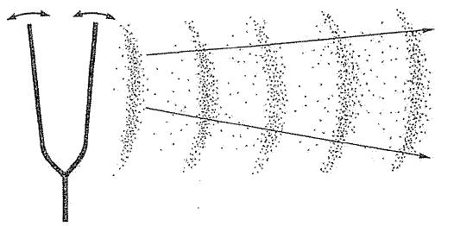

(2 marks)
25. Using the particle model theory, explain why sound travels at different speeds in each medium.

Gas –

Solid –

Liquid –

(3 marks)
26 What is meant by the frequency of a sound wave?
________________________________________________________________________________
________________________________________________________________________________
________________________________________________________________________________
(1 mark)
27 What is the unit of frequency? ________________________________ (1 mark
28 What unit is sound measured in? ________________________________ (1 mark)

29 What happens to the sound produced by a sound generator if the amplitude is increased?
________________________________________________________________________________
________________________________________________________________________________
________________________________________________________________________________
(1 mark)
30. What happens to the sound produced by a sound generator if the frequency is increased?
________________________________________________________________________________
________________________________________________________________________________
________________________________________________________________________________
(1 mark)
31. Fill out the table below. List all the structures as well as the functions of the selected parts.
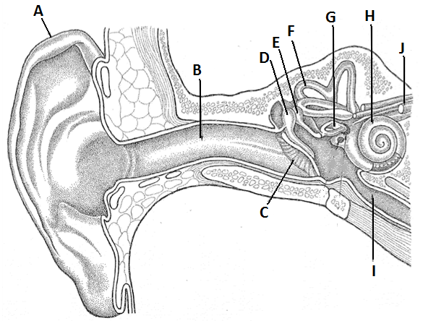
(10 marks)

Letter | Name | Function
B
C
D, E, G
F
H

32 Explain, using steps or diagrams, how to demonstrate the passage of a sound wave through air using a slinky spring.

(3 marks)
33 Why can no one hear you scream in space?

(2 marks)
34 (a) What is the difference between a transverse and a longitudinal wave?

(b) Which of these describes the travel of light?

(c) Which describes the travel of sound?

(2 marks)
35 Describe the molecular motion in hot objects compared to cold objects.

(2 marks)
36 Why does a metal expand when it is heated?

(2 marks)
37 a Which object contains the most thermal energy - a mug of hot chocolate at 50°C or a household
hot water tank at 50°C? (1 mark)

b Explain your choice in part a. (1 mark)

38 A vacuum flask is designed to keep liquids hot. Match the design features of the flask with the way in which they cut down heat loss using lines between the columns.

Design feature | How it cuts down heat loss
Tight-fitting lid | Insulation; reduces heat loss by convection
Double glass walls | Insulation; reduces heat loss by conduction
Vacuum (no particles) between the two glass walls | Reflects radiant heat and reduces heat loss through the walls
Silver lining | Reduces convection in the air space above the liquid

(4 marks)

39 Paramedics at a disaster scene often wrap shiny silver ‘space blankets’ around casualties.
a Is a space blanket a conductor or an insulator? (1 mark)

b Why is the space blanket silver rather than black? (1 mark)

40 A group of students placed thermometers under squares of black paper, white paper and aluminium foil of equal sizes. They recorded the temperatures shown by the thermometers every minute for 5 minutes and obtained the following results:

Time (minutes) | Temp. square 1 (°C) | Temp. square 2 (°C) | Temp. square 3 (°C)
0 | 24 | 24 | 24
1 | 25 | 26 | 28
2 | 26 | 28 | 32
3 | 27 | 29 | 35
4 | 28 | 30 | 40
5 | 29 | 31 | 45

Identify the colour of each of squares 1 to 3.
1.
2.
3. (3 marks)
41 Name the three main parts of the eye that start with the following letters and explain their function in the eye.

a p ____________________
Function

b l ____________________
Function

c o ____________________ n ____________________
Function

(6 marks)

